**Personal, Relevant Background and Future Goals Statement**

# Motivation and Preparation to Pursue an Advanced Degree

When I was in fifth grade, the school held a science fair. My dad helped me to design and build a high voltage arc – known as Jacob’s ladder – and I won the grand prize! The science behind this experiment was simple, but I was hooked. Since that moment, I have loved engineering. The excitement of research and thrill of developing technology that can improve the world enthralls me. During my undergraduate degree in mechanical engineering, I realized that I wanted to pursue an advanced degree which would enable me to do research that will benefit society. Nelson Mandela said, “Education is the most powerful weapon which you can use to change the world”. My education will empower me to have a career where I can perform cutting edge research, provide for my family, and benefit society. Following are a few of the most prominent experiences that have prepared me for graduate school.

## Los Alamos Dynamic Summer School – 2014

Los Alamos National Laboratory (LANL) was my first exposure to the world of research. Unmanned aerial vehicles (UAVs) are one of the most promising technologies in the fight to improve response time to survivors in a disaster scenario. One of the challenges in flying a UAV indoors via onboard visual feedback is encountering reflective and transparent barriers. Glass office partitions, windows, and mirrors can confuse the operator (or autonomous navigation system), reducing the ability to accurately identify the positions of people who need rescue. During this nine-week fellowship, I worked with two other students to design a multimodal sensing system capable of determining 1) whether a barrier was transparent, reflective, or opaque and 2) the distance and angle of approach to that barrier. I personally came up with the system architecture we ultimately chose to use, headed the mechanical design of our prototype, and designed and implemented the algorithms for determining the distance and angle of approach to the barriers.

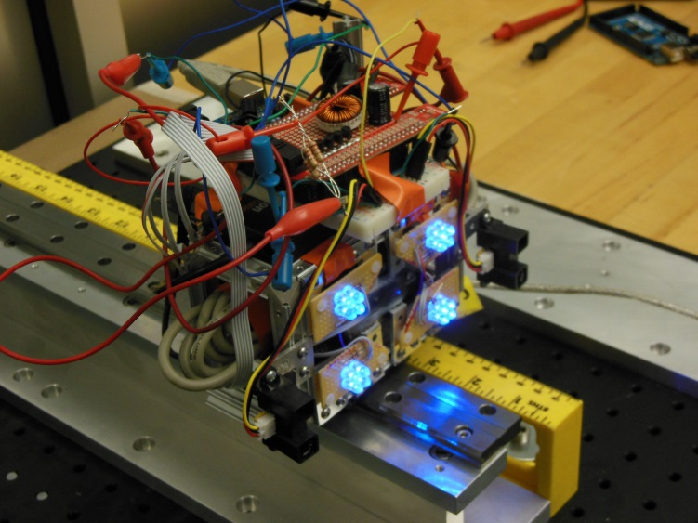

*Figure 1: Transpaerent barrier detection final prototype*

By the end of the fellowship, we had built and tested the successful prototype shown in *Figure 1*. We published our research in an SPIE conference paper [1], and I had the opportunity to individually travel to the conference to present our results. LANL left me amazed at the depth of knowledge my mentors possessed and gave me a burning desire to become a technical expert. Typically, it is technical experts who have the ability to contribute to the solutions of some of the world’s most difficult problems.

## BYU Tactile Sensor Development - 2015

After my experience at LANL, I sought out more research opportunities at Brigham Young University (BYU). Being particularly interested in dynamics and control, I decided to get involved with the BYU Robotics and Dynamics (RaD) lab under the direction of Marc Killpack. He told me that before I could join the lab, I needed to have a certain skill level in Python, Linux, and the Robot Operating System (ROS).To compensate for my lack of knowledge in these areas at the time, I spent much of my time outside of class and work completing tutorials and developing these necessary skills. As a result, I was able to join the lab and build my skills as a researcher. At the RaD lab, we work with pneumatically actuated soft robots (like Baymax from *Big Hero 6*). These soft robots are inherently safer around humans than traditional robots with high gear ratios. I worked with three other undergraduate students to develop an entirely fabric tactile sensor that wrapped around the inflatable robots in the lab to provide force feedback for control implementation. I wrote the microcontroller code to collect the data from the sensor, as well as the Python code to publish the force data in ROS. This sensor (shown in *Figure 2*) has now been implemented with a soft robot to perform movements while keeping the contact forces below a certain threshold. One of the broader impacts of this research is that these robots (already inherently safer around humans) will now be able to operate safely in an assistive role around individuals who are more fragile.

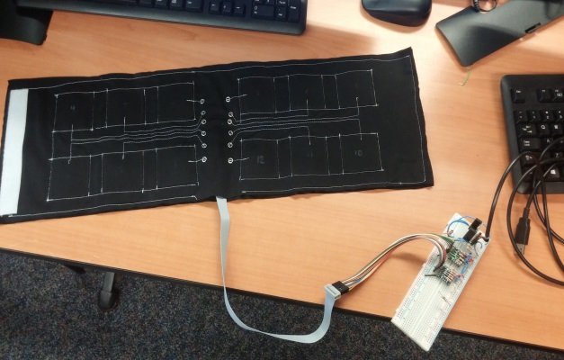

*Figure 2: Fabric tactile sensor*

One of my favorite parts of the RaD lab is the many outreach opportunities I’ve had as a lab member. I’ve helped give lab tours to new freshman to get them excited about research. I have also worked with other students in the lab to bring our robots to the Utah STEM Fest to encourage younger students (elementary, middle, and high school age) to participate in STEM. I loved watching the kids interact with the robots. Seeing the excitement on their faces reminded me of my own fifth grade science fair experiment.

## The Aerospace Corporation – 2016

This summer, I worked at a second federally funded research and development center, The Aerospace Corporation. While there, I worked primarily on three projects. First, I designed, built, and calibrated a testing setup to measure the thrust generation of a new type of UAV in Martian atmosphere. This included selecting vacuum compatible load cells, designing all of the mounting hardware in SOLIDWORKS, and writing the LabVIEW code to collect the data. Second, I was responsible for determining how much heat new thermoelectric cooling modules were capable of pumping. (The Aerospace Corporation was researching these modules as a potential replacement for cyrocoolers on satellites.) I designed a test plan and wrote a thermal PID controller in LabVIEW that controlled the temperature difference across the module. My LabVIEW code completely automated the data collection. To tune the PID controller, I performed system identification to create a first order model and simulated its response in Simulink. Third, I wrote a gradient based optimization in Matlab to orient six accelerometers on a reaction wheel jitter test stand (again using LabVIEW for data collection).

This internship reinforced my love of working in a research based environment. In addition, this experience in working with control system design on real hardware has been invaluable in preparing me for graduate research in controls and robotics.

# How Graduate School Will Prepare Me to Contribute to Expanding Scientific Understanding

## Continued Research

I am pursuing my master’s degree in the RaD lab at BYU. During my undergraduate degree, I took graduate classes in optimization, control theory, neuromechanics, and dynamics. I will take more advanced classes in these topics during my graduate degree. The technical skills I develop in these classes will build a base on which I can continue to perform advanced research in my career.

In addition to advanced coursework, during my graduate degree, I will do research into dual arm manipulation on soft, pneumatically actuated robots. As a part of this research, I will develop advanced dynamic models, write and implement controllers, and work with a variety of robots. This experience in solving open ended problems will be invaluable for my future career. I will also have the opportunity to present my research at multiple conferences where I will collaborate with other researchers in my field.

In short, my graduate degree will enable me to work shoulder-to-shoulder with other experts to address some of the nation’s most difficult problems.

## Future Career

My internships at The Aerospace Corporation and Los Alamos National Laboratory reinforced how important it is to me to be involved in cutting edge research. During both these internships and my undergraduate research, I made contributions that expanded scientific understanding. I fully intend on doing similar research for my future career. In fact, my research and experimentation at The Aerospace Corporation was received well enough that they kept me on as a casual employee while I work on my master’s degree, giving me the option of returning there after my graduate degree to contribute to the nation’s scientific understanding.

# How Graduate School Will Prepare Me to Broadly Benefit Society

## Giving Back

The entirety of my bachelor’s degree was paid for through academic scholarships, which allowed me to spend more time focusing on my research and classes. These scholarships are provided by the generosity of others. After graduating with my bachelor’s degree, I financially gave back a little already. When I finish my master’s degree and start my career, I plan to donate more generously to help other hard working students in STEM accomplish their ambitions.

## Volunteering

Throughout my life, I have demonstrated a pattern of regular service. In high school I did a service project each month as part of a church program while also working to earn my Eagle Scout award (designing and building a wheel chair accessible rest area on a community walking path for the community). After completing my first year of college, I spent two consecutive years as a volunteer missionary in Jamaica. During these years, I spent 16 hours a day teaching people about Jesus Christ and helping locals build houses, construct chicken coops, and clear farmland. I also taught regular seminars to other missionaries to help them become more efficient in their service. Since returning to school from my missionary service, I have participated in multiple outreach opportunities as a member of the RaD Lab where we demonstrated the lab’s research. In addition to this, I recently volunteered for a 10 week program focused on strengthening families where I worked with a group of at risk, minority teenagers once a week.

Technical demonstrations by the RaD lab graduate students greatly influenced my decision to pursue a graduate degree. I’m thrilled to be a part of this lab, and look forward to participating in similar outreach activities both during and after graduate school.

# Conclusion

Herbert Spencer stated, “The great aim of education is not knowledge but action.” This is how I feel about my education. Obtaining a graduate degree will empower me to help change the world, and I eagerly anticipate what lies ahead.

[1] I. Acevedo, R. Kaleb Kleine, D. Kraus, and D. Mascareñas, “Multimodal sensing strategies for detecting transparent barriers indoors from a mobile platform”, in *Proc. SPIE 9431, Active and Passive Smart Structures and Integrated Systems 2015*, 94310V, 2015.